Practical 8

**Problem Statement** - Implement MYSQL/ORACLE database connectivity with PHP/PYTHON/JAVA implement database navigation operations using JDBC/ODBC

# Code :

import java.sql.Connection; import java.sql.DriverManager; import java.sql.ResultSet; import java.sql.Statement;

public class Connect {

public static void main(String[] args) { try {

// Load MySQL JDBC Driver Class.forName("com.mysql.cj.jdbc.Driver");

// Establish connection to MySQL database Connection con = DriverManager.getConnection(

"jdbc:mysql://localhost:3306/student47", "root", "Feeld@nce143"

);

// Create statement object

Statement st = con.createStatement();

// Uncomment this if you need to create the table

// st.executeUpdate("create table s1(name varchar(25), roll int, marks int)");

// Insert values into the table

st.executeUpdate("insert into s1 values('Gaurav Pawar', 67, 95)"); st.executeUpdate("insert into s1 values('Aditya Sadavare', 68, 94)"); st.executeUpdate("insert into s1 values('Dagabaaz Nikam', 69, 90)"); st.executeUpdate("insert into s1 values('Chinmay Kamlaskar', 70, 85)"); st.executeUpdate("insert into s1 values('Somesh Gaikwad', 71, 75)");

// Select and print data from the table

ResultSet rs5 = st.executeQuery("select * from s1"); System.out.println("executed successfully");

while (rs5.next()) {

System.out.println(rs5.getString("name") + " " + rs5.getInt("roll") + " " + rs5.getInt("marks"));

}

// Update a record

int rs6 = st.executeUpdate("update s1 set name='tina' where roll=3"); System.out.println("Updated records: " + rs6);

// Drop view if it exists

st.executeUpdate("drop view if exists viewJDBCNamee");

// Create a view

st.executeUpdate("create view viewJDBCNamee as select name from s1");

// Fetch data from the view

ResultSet rs9 = st.executeQuery("select * from viewJDBCNamee"); while (rs9.next()) {

System.out.println("View name: " + rs9.getString(1));

}

// Alter table structure

st.executeUpdate("alter table s1 add admissionDate Date");

// Drop a column from the table

st.executeUpdate("alter table s1 drop column admissionDate");

// Close connections rs5.close();

rs9.close();

st.close();

con.close();

} catch (Exception ex) { System.out.println("Error: " + ex);

}

}

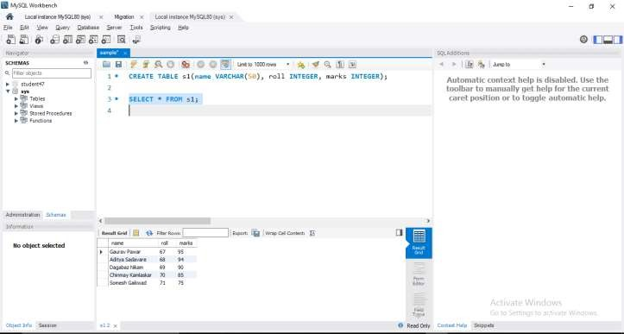**OUTPUT:**